INFO 5770
Type 2 Diabetes Final Report

Table of Contents
Introduction 3
Main Causes of Type 2 Diabetes 3
Treatment Options 3
Influential Factors 4
Research Questions 4
Related Work 5
Methods 6
Data Preprocessing 6
Descriptive Statistics 8
Demographics 8
Sex 8
Race 9
Age Group 10
Comorbidities 11
Hypertension 11
Cholesterol 12
Smoking Status 13
Results 14
Discussion 16
General Health Status: The Strongest Predictor: 16
Clinical Comorbidities: Anticipated Patterns 17
Age Effects: Healthcare Utilization across the Lifespan 18
Racial and Ethnic Disparities 18
Gender Differences: A Modest Effect 19
The Smoking Puzzle: A Non-Significant Result 20
Physical Activity Limitations 20
Correlations with Continuous Variables 21
Limitations and Considerations 21
Reflection 22
Conclusion 23
References 25

Introduction

Title | Type 2 Diabetes Final Report
Medical Condition | Type 2 Diabetes
Team Members | Manju Bhargavi Annem (ma2159) - Discussion and Conclusion  Evan Dunn (egd0022) - Writing the report, PowerPoint review, report review  Brett Porter (bp0288) - Writing the report, PowerPoint, Coding  Maria Shiferaw (ms2526) - Coding and PowerPoint

Type 2 diabetes (T2D) continues to be one of the most significant chronic health conditions in the United States, making the analysis of its patterns and associated factors essential for improving prevention, treatment, and long term management strategies. Using nationally representative data from the Medical Expenditure Panel Survey (MEPS), this study examines key demographic, behavioral, and clinical differences within the T2D population.

Main Causes of Type 2 Diabetes
- Insulin Resistance - Cells do not respond properly to insulin and do not intake enough sugar
- Inadequate Insulin Production - Pancreas cannot produce enough insulin to keep blood sugar levels in a healthy range

Treatment Options
First line treatment usually includes dieting by reducing refined carbohydrates and sugars, while focusing on whole grains, lean protein, vegetables, and healthy fats. 150 minutes of moderate physical activity every week helps the body use insulin more effectively. Other recommendations include quitting smoking and keeping alcohol consumption to a minimum. Oral medications like Metformin can improve insulin sensitivity and lower the risk of low blood sugar. Injectable medications like GLP-1 slows digestion, increases insulin, and reduces appetite. Thanks to modern technology, blood sugar can be monitored and provides continuous data for better tracking, preventing highs and lows, and allows for treatment to be tailored more precisely.

Influential Factors
Type 2 diabetes comes from a combination of genetic, lifestyle, and environmental influences that collectively impair the body’s ability to regulate glucose. Genetic predisposition and family history increase susceptibility by affecting insulin production and sensitivity. Lifestyle factors, such as poor diet, physical inactivity, and excess body weight are among the largest contributors of creating insulin resistance. Additional factors include chronic stress and being over the age of 35.

Research Questions
- Do age groups and race/ethnicity differ among Type 2 Diabetes patients?
- How does physical activity vary across sex and race?
- Is the mean Total Off-Based Dr Expenditures significantly different based on a patient’s Race or the presence of specific comorbidities (e.g., HIBPDX, CHOLDX)?

Related Work
Research shows that Type 2 Diabetes (T2D) is a disease that reveals significant differences based on socioeconomic status and demographics. Patient outcomes are often influenced more by non-clinical factors than by biological ones. Large population health studies, like the Medical Expenditure Panel Survey (MEPS), have shown that variations in race, ethnicity, and age within T2D groups are very important. For instance, many non-White individuals, especially Black and Hispanic individuals, usually get diagnosed with T2D at younger ages compared to White individuals, which leads to a greater lifetime impact of the disease (Golden, Yajnik, Phatak, Hanson, & Knowler, 2019). Additionally, these demographics are closely linked to the occurrence of other chronic health issues. For example, older age in certain racial groups often results in higher rates of hypertension and high cholesterol, making it essential to carefully analyze and model these factors to prevent mixing up the results with the underlying demographic characteristics (American Diabetes Association Professional Practice Committee, 2022).
In addition to immutable demographic traits, factors related to behavior like physical activity level and smoking status are seen as key areas for intervention in managing T2D. Research consistently highlights the protective benefits of physical activity, which enhances insulin sensitivity and lowers cardiovascular risk, making it a significant factor in outcomes such as coronary heart disease and high cholesterol (Zheng, Ley, & Hu, 2018). Importantly, studies indicate that these health behaviors are not evenly distributed throughout the population. There are notable sex-based differences in physical activity levels, with men typically reporting more involvement in vigorous activities, while women often participate more in moderate activities or show lower overall levels. Understanding these relationships, particularly how sex connects to physical activity levels without the influence of race, is crucial for creating targeted public health strategies that go beyond generic clinical advice and cater to the specific behavioral risk profiles of different subgroups within the T2D patient community.

Methods

Data Preprocessing
1. Data Loading
Two CSV files were loaded:
Condition file (h214.csv) containing ICD-10 codes.
Person-level file (h216.csv) with demographic and clinical variables.
2. Diabetes Cohort Selection
Identified diabetes cases using ICD-10 prefixes: E10-E14.
Extracted unique patient IDs (DUPERSID) for those cases.
Merged with person-level data to create a diabetes cohort.
3. Variable Selection
Selected ~10-15 candidate variables from demographics, lifestyle, and comorbidities:
DUPERSID, AGE53X, SEX, RACETHX, HISPANX, EDUCYR, ADGENH42, ADSMOK4, HIBPDX, CHOLDX, LFTDIF31, OBDEXP19
4. Remove Indiscriminate Variables
Dropped columns with no variance
5. Handle Missing Values
Converted MEPS special codes (e.g., -1, -7, -8, -9, -996-999) to NaN.
Imputed:
Numeric columns→ mean.
Categorical columns → mode.
6. Outlier Removal
Applied IQR rule (1.5x) on numeric columns
Reduced dataset from 2508 to 2289
7. Redundancy Checks
Numeric: Drop highly correlated columns (Pearson |r| ≥ 0.85).
Categorical: Drop columns with strong association (Cramer’s V ≥ 0.80 and p < 0.001).
Determined that no columns should be dropped
8. Standardization and Normalization
Standardization: MinMaxScaler
Normalization: None

Descriptive Statistics

Demographics

Sex
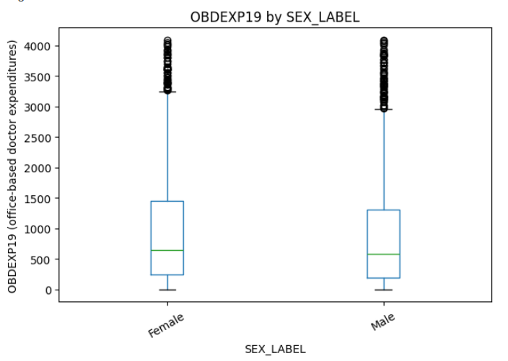
The box plot shows that female patients have a higher median expenditure, and that the entire distribution of costs is highly skewed for both sexes due to a long tail of high-cost patients.

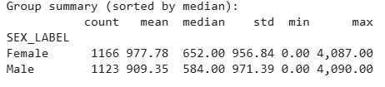
Female patients incurred a median expenditure of $652.00 for off-based physician services, which was 11.6% higher than the median expenditure of Male patients ($584.00)

Race
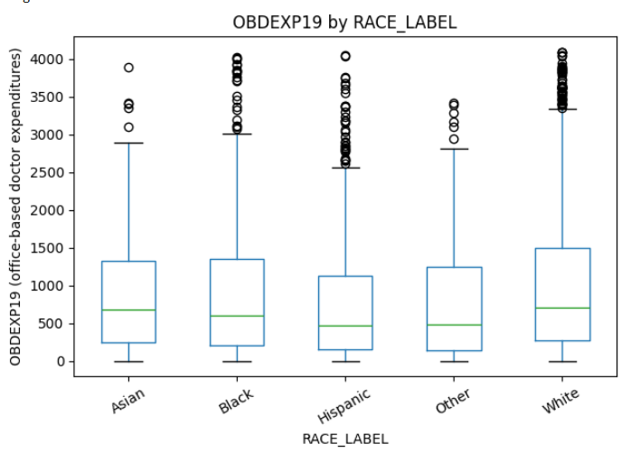
White patients have the highest median expenditure. All five box plots show numerous outliers that make the distribution highly skewed.
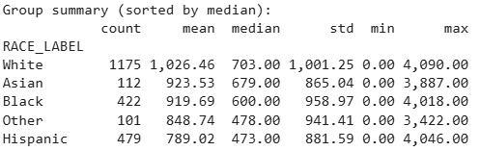
The highest median expenditures were observed for the White group ($703.00), followed by the Asian group ($679.00). The Hispanic group ($473.00) and Other group ($478.00) had the lowest median expenditures.

Age Group
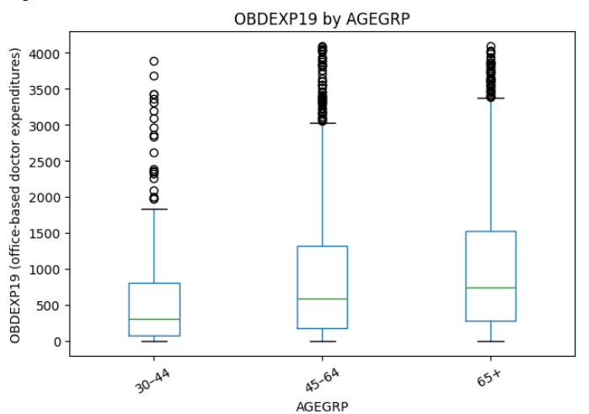
There is a statistically significant difference in total off-based doctor expenditures among age groups AGEGRP (H = 72.18, p = 0.000). Due to the extremely low value of p, the probability that these differences are due to random chance is practically zero. Our patients with T2D who are older in age, are likely to have higher medical expenditures. Diabetes aside, people tend to develop more health issues as they get older, and the high amount of expenditures could be related to older people having multiple overlapping conditions, which would result in additional treatments, and higher bills as a result.

Comorbidities

Hypertension
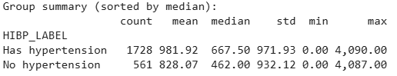
The median expenditure for patients managing hypertension is 44.3% higher than for those without the condition.
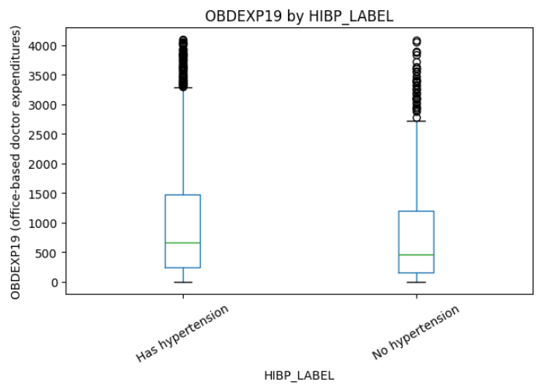

Cholesterol
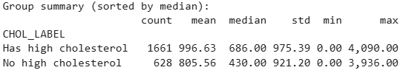
Patients with high cholesterol had a median expenditure of $686.00. Patients without high cholesterol had a median expenditure of $430.00. The expenditure of those with high cholesterol was 59.5% higher than for those without the condition.
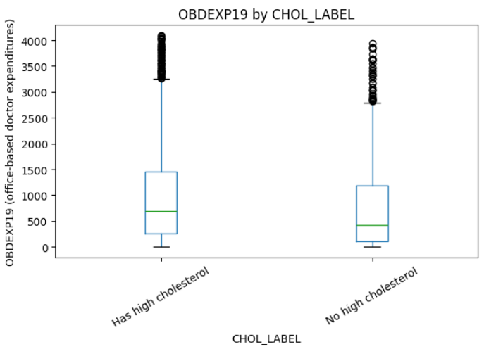
Both boxes show the median line positioned closer to the bottom (Q1). This strongly indicates that the distribution of expenditures for both groups is severely positively skewed. Most patients fall into the low-to-moderate cost bracket, but a small minority of high-cost cases stretch the distribution.

Smoking Status
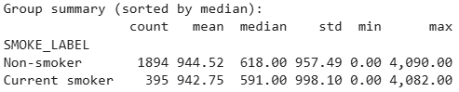
The median expenditure for non-smokers was $618.00. The median expenditure for Current Smokers was $591.00. This was a 4.5% difference between Non-smokers and Current smokers.
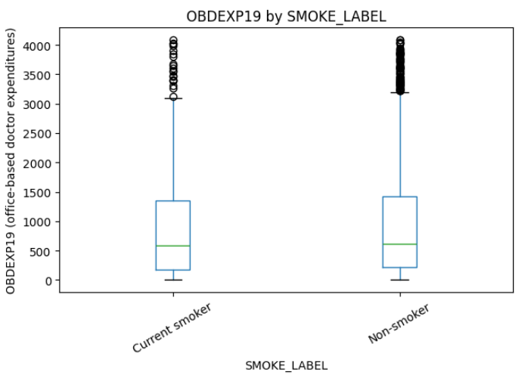
The median line for Non-smokers and Current smokers is visually only slightly higher.

Results
Do age groups and race/ethnicity differ among Type 2 Diabetes patients?
There is a highly statistically significant association between a patient’s Race/Ethnicity and their Age Group (chi^2(8, N=2,285) = 68.1165, p < 0.001). The strength of this relationship is considered moderate (Cramer’s V = 0.1146). This significance means that the distribution of patients across age groups is not the same for all racial/ethnic categories.

How does physical activity vary across sex and race?
There is a highly significant association between a patient's Sex and their Physical Activity Level (chi^2(1, N=2,285) = 13.70, p = 0.0002). The association is weak but meaningful (Cramer's V = 0.0745).
There is an even stronger and highly significant association between Race/Ethnicity and Physical Activity Level (chi^2(4, N=2,286) = 42.29, p < 0.001). The association is stronger than the sex relationship (Cramer's V = 0.1294).
The "Other" race group shows the highest proportion of limited physical activity (19.80%), followed closely by the White group (14.30%). Conversely, the Asian group reports the lowest proportion of limited physical activity (3.57%). This wide variance confirms that targeted interventions for T2D management must account for race/ethnicity.

Is the mean Total Off-Based Dr Expenditures significantly different based on a patient’s Race or the presence of specific comorbidities (e.g., HIBPDX, CHOLDX)?
Race/Ethnicity was highly significantly associated with Total Off-Based Dr Expenditure (H = 27.65, p < 0.001). The highest median expenditures were observed for the White group ($703.00), followed by the Asian group ($679.00). The Hispanic group ($473.00) and Other group ($478.00) had the lowest median expenditures. This confirms an economic disparity in physician utilization or cost burden across racial groups.
The presence of both hypertension and high cholesterol are highly significant predictors of higher expenditure (p<0.001 for both). Patients with Hypertension (HIBP_LABEL) had a median expenditure of $667.50, which is significantly higher than those without ($462.00). There is a highly statistically significant difference in the distribution of Total Off-Based Dr Expenditures (OBDEXP19) between patients with and without hypertension (H = 16.33, p < 0.001).

Discussion

General Health Status: The Strongest Predictor
The most striking finding of our analysis was the strong association of general health status with office-based doctor expenditures. With H approximately equal to 59.40, p < 0.001, patients rating their health as "Poor" had median expenditures of $1,061.50, over three times as high as patients rating their health as "Excellent," at $317.00. This result is both meaningful and logically consistent with clinical expectations.
This pattern probably occurs for several reasons. First, individuals with Type 2 Diabetes who report poor general health may be suffering from more complications or comorbidities, thus necessitating more frequent doctor visits and more interventions. Second, poor health status could reflect poor disease management, resulting in acute episodes necessitating additional doctor visits. Third, the relationship may go both ways: those with worse health outcomes require more medical care, and more medical interactions may also raise awareness of health problems, leading to lower self-rated health.
The clear gradient across all five health categories Poor > Fair > Very Good > Good > Excellent suggests that self-rated health status serves as a useful proxy for disease burden and complexity in Type 2 Diabetes patients. This finding has important implications for healthcare resource allocation and patient risk stratification.

Clinical Comorbidities: Anticipated Patterns
Among chronic conditions, both hypertension and high cholesterol were significantly associated with higher expenditures, p < 0.001 for both. Patients with hypertension had a median expenditure of $667.50 compared to $462.00 for those without hypertension, H = 16.34, p < 0.001; similarly, those with high cholesterol spent a median of $686.00 versus $430.00 for those without, H = 31.88, p < 0.001.
These findings agree with the clinical understanding of Type 2 Diabetes in that hypertension and hyperlipidemia are usual comorbidities in diabetic patients and constitute the constellation of metabolic syndrome. Patients with these conditions naturally require additional monitoring, medication management, and treatment, which corresponds to increased healthcare utilization. The stronger association for cholesterol, H = 31.88, compared to hypertension, H = 16.34, may reflect the additional complexity and urgency of managing cardiovascular risk factors in diabetic patients.

Age Effects: Healthcare Utilization across the Lifespan
Age group was strongly associated with expenditures: H = 63.29, p < 0.001; this was due to a clear increasing trend: 30-44 years, $302.50; 45-64 years, $593.00; 65+ years, $746.00. This reflects a number of underlying mechanisms.
First, older patients typically have a longer duration of diabetes, associated with increased complications and comorbidities. Second, the 65+ group becomes Medicare-eligible, which may reduce financial barriers to healthcare access, leading to more frequent doctor visits. Third, aging itself brings additional health concerns beyond diabetes, increasing overall healthcare utilization. Such notably low expenditure in the 30-44 age group may indicate either better disease management in younger patients with fewer complications, or perhaps underutilization of healthcare services due to the demands of work and family.

Racial and Ethnic Disparities
Race was statistically significant for health care expenditures, with H = 27.66, p < 0.001. By race, the median expenditure is as follows: White, $703.00; Asian, $679.00; Black, $600.00; Other, $478.00; Hispanic, $473.00. This finding is puzzling and concerning; it runs counter to the expected pattern where often, the minority populations experience worse diabetes outcomes.
Several explanations are possible for this pattern. First, this could represent disparities in healthcare access rather than in healthcare needs. Lower expenditures among Hispanic and Other race patients may signal barriers to care, including lack of insurance or language barriers or systemic discrimination in healthcare settings. Second, cultural differences in healthcare-seeking behavior might play a role. Third, the higher expenditures in White patients could reflect better insurance coverage or greater ability to afford out-of-pocket costs, leading to more frequent preventive care visits.
Importantly, our data captures expenditure and does not account for outcomes. Results could easily indicate that Hispanic and Black patients have lower expenditures but worse health outcomes, which would be a formidable concern for health equity. The chi-square analysis showing significant associations between race and both physical activity limitations (Cramer's V = 0.13) and age groups (Cramer's V = 0.11) suggests these demographic patterns are interconnected in complex ways.

Gender Differences: A Modest Effect
The median expenditures for female patients were slightly higher than that of males: $652.00 versus $584.00, with H = 7.09, and p = 0.008. Although statistically significant, this is a relatively small difference. There are several reasons that may account for this finding. First, women are more likely to practice preventive health behaviors and seek routine physician visits. Second, women with diabetes are in a unique position regarding pregnancy, hormonal fluctuations, and possibly dissimilar cardiovascular risk profiles, necessitating more visits to doctors.
Chi-square analysis showed that female respondents were less likely than men to report limitations in physical activities, with Cramer's V of 0.07 and a p-value of less than 0.001, which is somewhat puzzling in light of their higher expenditures. This may indicate that higher healthcare utilization by women is more preventive care and not related to disability needs.

The Smoking Puzzle: A Non-Significant Result
Surprisingly, smoking status was not associated significantly with office-based doctor expenditures, as shown by H = 0.28, p = 0.595, where current smokers reported a median expenditure of $591.00 as compared to non-smokers at $618.00. This finding is bewildering and runs opposite to expectations based on clinical knowledge, since smoking is an established risk factor for diabetes complications.
Several explanations for this unexpected result exist. First, diabetic smokers may have more acute complications requiring emergency department visits or hospitalizations, which we would not capture in our office-based expenditure data. Second, there may be a survivorship bias wherein diabetic smokers with the most severe complications are no longer represented in this ambulatory care dataset. Third, smokers may engage less in preventive healthcare and routine doctor visits, even though they may have greater medical needs. Finally, the relatively small sample of current smokers, n = 395, versus non-smokers, n = 1,894, may have made it difficult to detect a true difference.

Physical Activity Limitations
Physical activity limitations were significantly related to expenditures, with H = 5.98, p = 0.014, and with a higher median expenditure of those reporting limitations ($744.00 vs $606.00). Clinically, this makes sense because activity limitation is a sign of more advanced disease or complications. Chi-square analyses produced the following interesting patterns: physical activity limitations were associated both with race, Cramer's V = 0.13, p < 0.001, and with sex, Cramer's V = 0.07, p < 0.001, but with weak effect sizes. This indicates that while these demographic factors relate to activity limitations, the relationships are complex and likely mediated by other factors such as socioeconomic status, access to exercise facilities, and cultural attitudes toward physical activity.

Correlations with Continuous Variables
For all relationships, correlation analysis gave weak but significant positive correlations of expenditures with age (r = 0.13) and education years (r = 0.08). The age correlation is in agreement with the pattern found in our categorical age group analysis. The positive association with education seems counterintuitive, since higher educational attainment usually implies better health. Here, however, it could mean that the more educated have better health insurance, are more knowledgeable about health and thus have more healthcare-seeking behaviors or have better access to health services. Alternatively, this may be an indirect measure of income and employment status related to insurance coverage.

Limitations and Considerations
There are a number of limitations that must be considered in interpreting these findings. First, our analysis is cross-sectional; thus, we cannot determine causality. Second, we only evaluated office-based doctor expenditures, excluding emergency department visits, hospitalizations, and prescription medications, among other health care services. A patient with lower office-based expenditures may actually incur higher overall health care costs due to poor disease management resulting in acute care episodes. Third, expenditure data may be affected by insurance coverage patterns and system-of-care factors beyond individual patient characteristics. Fourth, for some subgroups (e.g., excellent health rating, n = 63), our relatively small sample sizes may limit the generalizability of findings.
Additionally, there are important clinical variables that are not captured in our data, such as HbA1c levels, duration of diabetes, specific complications, or medication adherence, which might give a more detailed understanding of the relationships observed. The finding that general health status is such a strong predictor might partly reflect that it serves as a proxy for these unmeasured clinical factors.

Reflection

Over the course of the semester, this introduction to health data analytics course gave us a deeper understanding of how data can be used to answer research questions in healthcare. One of the best parts of this course was learning how to work with real world datasets like the Medical Expenditure Panel Survey (MEPS). Using MEPS data allowed us to apply statistical concepts to actual patient information, which helped us better understand the key factors that influence medical expenditures.
We learned how to use Python to perform data analysis. By loading, cleaning, and analyzing large datasets, we could identify negative values that needed to be removed, and generate visuals to explore distributions. Working with Python helped us understand how data types like categorical and numerical variables, can impact the types of analyses that we can perform. Another focus of this course was understanding and applying statistical concepts like skewness, kurtosis, and normality.
We learned that many standard parametric tests like the t-test or ANOVA, are not appropriate when the data is non-normal or heavily skewed. Instead, we should use non-parametric tests like the Mann-Whitney U test and the Kruskal-Wallis test, which do not rely on a normalized dataset and are better suited for health data. The emerging field of health data analytics has enormous potential to change how healthcare organizations understand patients, improve clinical outcomes, and reduce costs.
Maybe in the future we will see these large datasets be used to show median costs of expenditures so that people won’t be overpaying for their medical bills. Some of the barriers we saw while conducting analysis were messy or incomplete data, statistical complexity, privacy constraints, and the need for strong technical skills. Overcoming these barriers is necessary for the success of health data analytics.

Conclusion

This thereby suggests that age, self-rated health, chronic disease status, physical limitations, sex, and race are very strong determinants of office-based healthcare expenditures. Of all the variables considered, general health status and age were the strongest predictors of medical spending, with poor health and older age linked to dramatically higher costs. Chronic conditions such as hypertension and high cholesterol further raised expenditures, with the financial burden of long-term disease management thus emphasized.
These findings are important because they help identify high-risk populations that drive healthcare utilization and costs. Understanding these patterns enables policymakers, clinicians, and healthcare administrators to better allocate resources, enhance preventive care strategies, and design targeted interventions for older adults and individuals with chronic disease. Moreover, the racial and sex disparities in spending observed point to an ongoing need for more equitable access to preventive and primary care services.
Overall, this project demonstrates how analytics in health data can uncover significant patterns both in population health and healthcare utilization that can give actionable insights to improve efficiency, reduce disparities, and help in promoting patient-centered care.

References
American Diabetes Association Professional Practice Committee. (2022). 1. Improving care and promoting health in populations: Standards of medical care in diabetes—2022. Diabetes Care, 45(Suppl. 1), S8–S16. https://doi.org/10.2337/dc22-S001
Golden, S. H., Yajnik, C., Phatak, S., et al. (2019). Racial/ethnic differences in the burden of type 2 diabetes over the life course: A focus on the USA and India. Diabetologia, 62(10), 1751–1760. https://doi.org/10.1007/s00125-019-4968-0
Zheng, Y., Ley, S., & Hu, F. (2018). Global aetiology and epidemiology of type 2 diabetes mellitus and its complications. Nature Reviews Endocrinology, 14(2), 88–98. https://doi.org/10.1038/nrendo.2017.151

